NOVEMBER 2019
REPORT OF EXAMINATION | 2019M-169
DIVISION OF LOCAL GOVERNMENT AND SCHOOL ACCOUNTABILITY
Town of Moriah
Cash Management

Contents

Report Highlights . . . . . . . . . . . . . . . . . . . . . . . . . . . . 1
Cash Management . . . . . . . . . . . . . . . . . . . . . . . . . . . . 2
How Do Officials Ensure Interest Earnings Are Maximized? . . . . . 2
Officials Did Not Ensure Interest Earnings Were Maximized . . . . . 2
What Do We Recommend? . . . . . . . . . . . . . . . . . . . . . . 3
Appendix A – Response From Town Officials . . . . . . . . . . . . . 4
Appendix B – Audit Methodology and Standards . . . . . . . . . . . 5
Appendix C – Resources and Services . . . . . . . . . . . . . . . . . 6

Report Highlights
Town of Moriah
Background
The Town of Moriah (Town) is located in Essex County.
An elected five-member Town Board (Board), which is composed of the Town Supervisor (Supervisor) and four Board members, is responsible for the general oversight of the Town’s operations and finances. The
Supervisor, as chief fiscal officer, is responsible for receiving, disbursing, investing and retaining custody of Town money and providing financial reports to the Board.
The Town has funds on deposit at one financial institution. Bank accounts are maintained for operating and capital projects funds, a nonexpendable trust fund and departmental funds (i.e., Town Clerk, Tax Collector and Town Justices).
Quick Facts
Population | 4,800
Adopted Appropriations | $5.2 million
Interest Earnings During the  Audit Period (Operating and  Capital Projects Funds) | $4,703
Audit Period
January 1, 2018 – May 31, 2019

Audit Objective
Determine whether Town officials maximized interest earnings.

Key Findings
● The Board did not develop and manage a comprehensive investment program to ensure interest earnings were maximized.  Had the Supervisor invested available funds in a
financial institution with higher available interest rates, revenue would have increased by $80,688 during the audit period.

Key Recommendations
● Periodically solicit interest rate quotes from multiple financial institutions.  Prepare monthly cash flow forecasts that estimate available funds for investment.  Ensure available funds are invested in a manner,
within legal limits, to maximize interest earnings.
Town officials generally agreed with our recommendations and have initiated, or indicated they planned to initiate, corrective action.

Cash Management

How Do Officials Ensure Interest Earnings Are Maximized?
The board should develop and manage a comprehensive investment program. A comprehensive program should include the board adopting and annually reviewing an investment policy in accordance with New York State General Municipal Law (GML), soliciting interest rate quotes from multiple financial institutions, preparing monthly cash flow forecasts to estimate available funds for investment and investing available funds (within legal limits) in financial institutions offering the highest interest rates balanced with the acceptable risk. Once established, the board should monitor the program to ensure interest earnings are maximized.
Officials Did Not Ensure Interest Earnings Were Maximized
The Board did not develop and manage a comprehensive investment program to ensure interest earnings were maximized within acceptable risk levels. For example, although the Board adopted an investment policy in November 1988, it did not annually review the policy as required by GML to keep the policy current with available market conditions. During the audit period, Town officials did not solicit interest rate quotes from additional financial institutions or prepare any cash flow forecasts to estimate the amount of funds available for investment.
The Supervisor maintained the Town’s operating and capital projects funds at one financial institution. During the audit period, operating and capital projects funds were deposited in 14 interest-bearing checking accounts, which received interest rates of either .05 percent or .1 percent, and six non-interest-bearing checking accounts. As a result, the Town realized interest earnings of $4,703 related to its operating and capital projects funds during the audit period.
The Town maintains its operating and capital project funds in various checking accounts and pays claims and payroll from accounts as needed. However, by keeping unused money in checking rather than savings accounts, the Town is not maximizing its interest earnings. We identified the funds that were not needed to pay operating and capital project expenditures each month and found that the Town could have invested available operating and capital projects funds averaging approximately $3.2 million during the audit period in another financial institution with higher available interest rates of between 1.13 percent and 2.33

percent, or an average interest rate of 1.89 percent during the audit period. If the Supervisor had invested these funds in this financial institution, interest earnings would have totaled $85,391 during the audit period (an increase of $80,688).
Because the Board did not develop and manage a comprehensive investment program, the Town did not realize significant potential revenues.
What Do We Recommend?
The Board should:
- Annually review, and update if appropriate, the Town’s investment policy as required by GML.
- Ensure interest rate quotes are periodically solicited from multiple financial institutions.
- Ensure available funds are invested in a manner, within legal limits, to maximize interest earnings.
The Supervisor should:
- Prepare and provide the Board with monthly cash flow forecasts that estimate the amount of funds available for investment.

Appendix A: Response From Town Officials
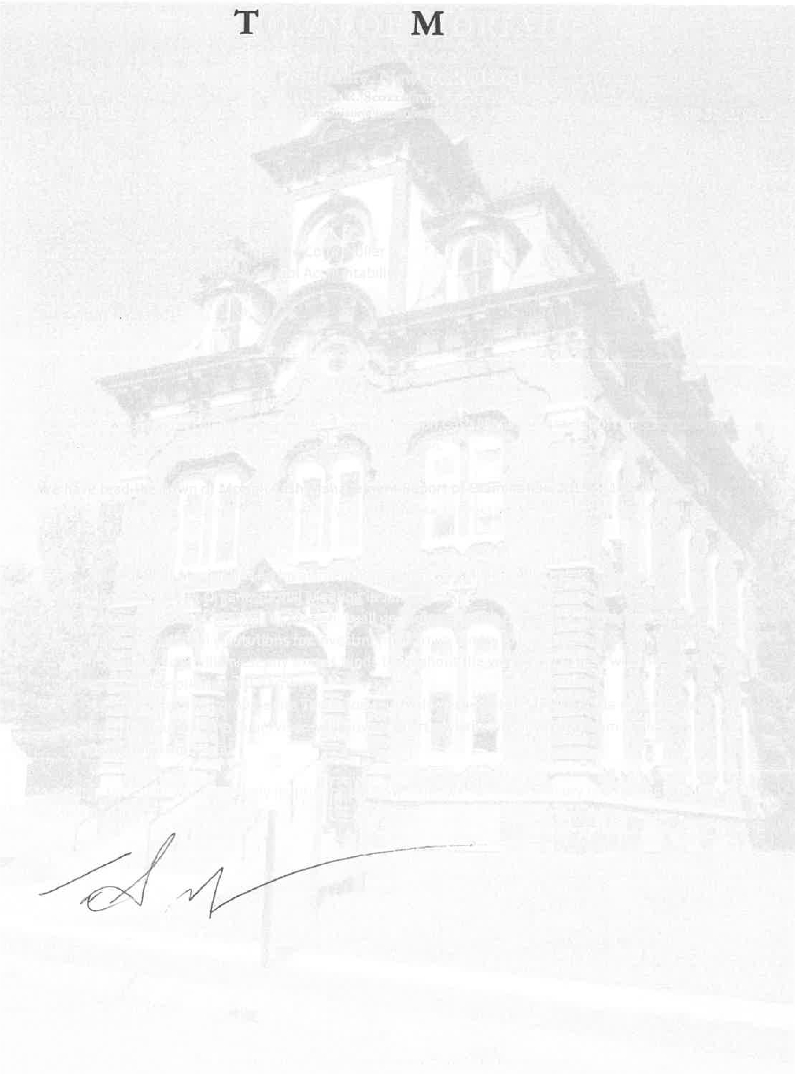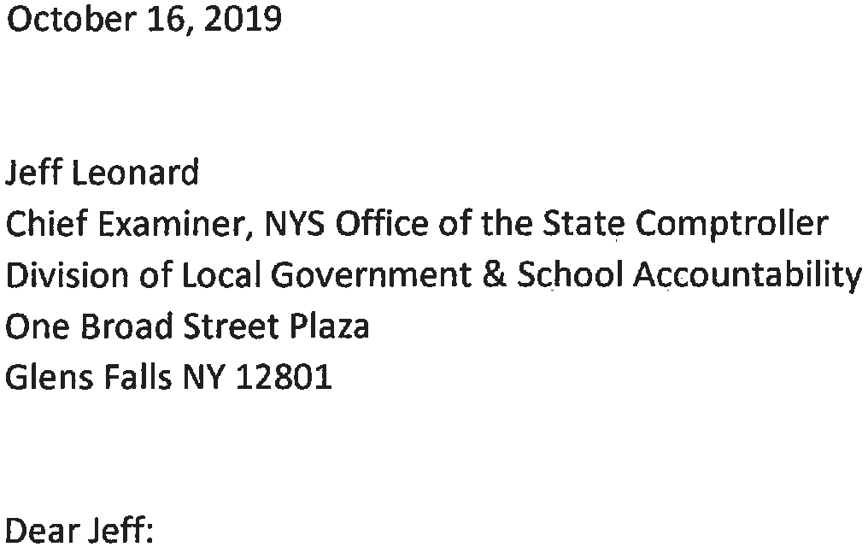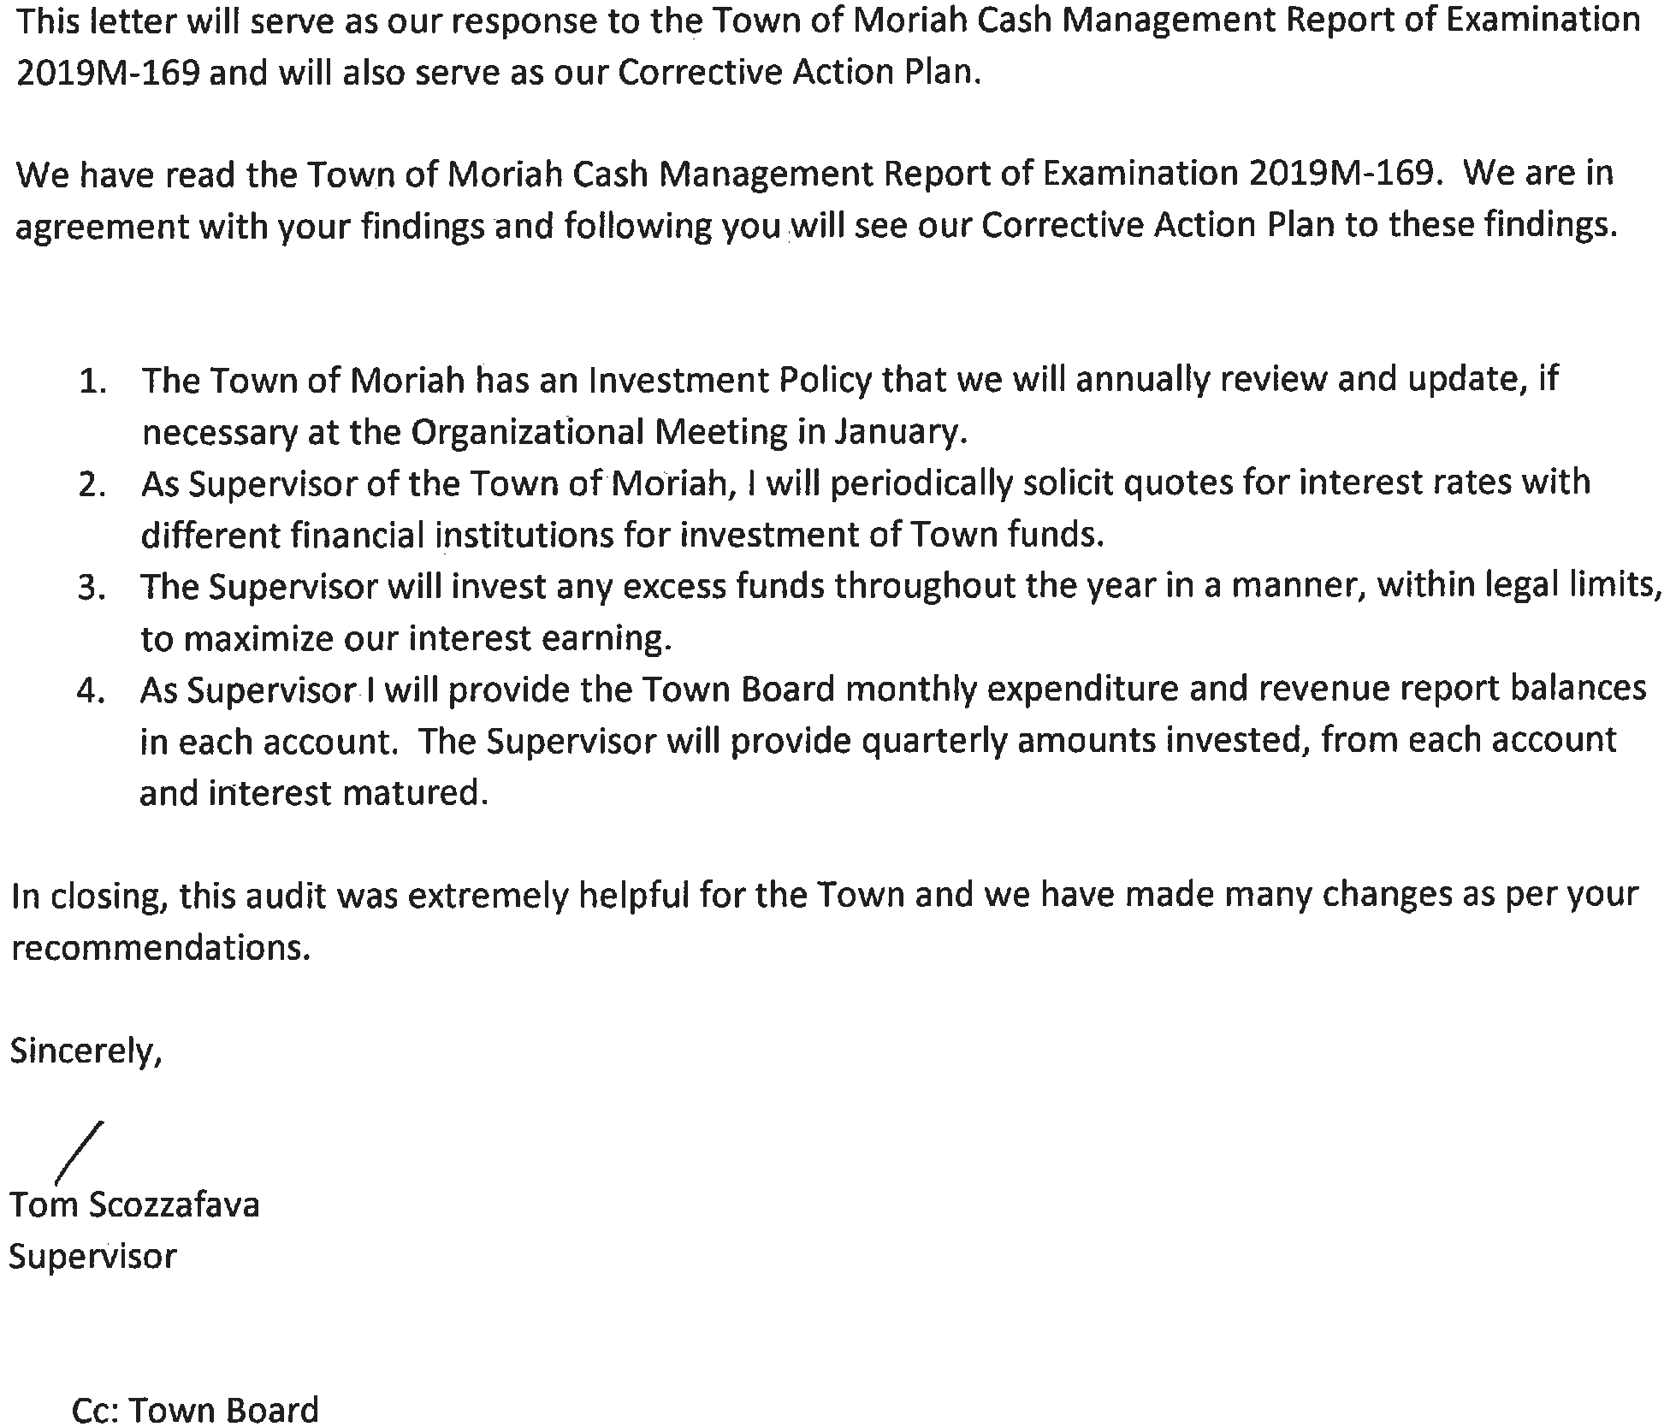

Appendix B: Audit Methodology and Standards

We conducted this audit pursuant to Article V, Section 1 of the State Constitution and the State Comptroller’s authority as set forth in Article 3 of the New York State General Municipal Law. To achieve the audit objective and obtain valid audit evidence, our audit procedures included the following:  We interviewed Town officials and reviewed the Town’s investment policy and various financial records to gain an understanding of the Town’s cash management procedures. This included inquiries regarding the Board’s annual review of the investment policy, soliciting interest rate quotes from financial institutions and the preparation of cash flow forecasts.  We reviewed all bank statements for the operating and capital projects fund
bank accounts during the audit period and analyzed the corresponding cash balances to determine the amount of funds available to be invested each month during the audit period. We then calculated the amount of interest earnings that could have been realized by the Town during the audit period had the available funds been invested in another financial institution. We selected this financial institution because it did not require minimum investment amounts and allowed for funds to be withdrawn at any time without penalties or fees, and because the daily interest rates during the audit period were publicly available. We then compared our calculated amount of interest earnings that could have been realized to the interest earnings actually realized by the Town during our audit period.
We conducted this performance audit in accordance with GAGAS (generally accepted government auditing standards). Those standards require that we plan and perform the audit to obtain sufficient, appropriate evidence to provide a reasonable basis for our findings and conclusions based on our audit objective. We believe that the evidence obtained provides a reasonable basis for our findings and conclusions based on our audit objective.
A written corrective action plan (CAP) that addresses the findings and recommendations in this report should be prepared and provided to our office within 90 days, pursuant to Section 35 of General Municipal Law. For more information on preparing and filing your CAP, please refer to our brochure, Responding to an OSC Audit Report, which you received with the draft audit report. We encourage the Board to make the CAP available for public review in the Town Clerk’s office.

Appendix C: Resources and Services

Regional Office Directory
www.osc.state.ny.us/localgov/regional_directory.pdf
Cost-Saving Ideas – Resources, advice and assistance on cost-saving ideas www.osc.state.ny.us/localgov/costsavings/index.htm
Fiscal Stress Monitoring – Resources for local government officials experiencing fiscal problems
www.osc.state.ny.us/localgov/fiscalmonitoring/index.htm
Local Government Management Guides – Series of publications that include technical information and suggested practices for local government management www.osc.state.ny.us/localgov/pubs/listacctg.htm#lgmg
Planning and Budgeting Guides – Resources for developing multiyear financial, capital, strategic and other plans
www.osc.state.ny.us/localgov/planbudget/index.htm
Protecting Sensitive Data and Other Local Government Assets – A nontechnical cybersecurity guide for local government leaders www.osc.state.ny.us/localgov/pubs/cyber-security-guide.pdf
Required Reporting – Information and resources for reports and forms that are filed with the Office of the State Comptroller www.osc.state.ny.us/localgov/finreporting/index.htm
Research Reports/Publications – Reports on major policy issues facing local governments and State policy-makers www.osc.state.ny.us/localgov/researchpubs/index.htm
Training – Resources for local government officials on in-person and online training opportunities on a wide range of topics www.osc.state.ny.us/localgov/academy/index.htm

Contact
Office of the New York State Comptroller
Division of Local Government and School Accountability
110 State Street, 12th Floor, Albany, New York 12236
Tel: (518) 474-4037 • Fax: (518) 486-6479 • Email: localgov@osc.ny.gov www.osc.state.ny.us/localgov/index.htm
Local Government and School Accountability Help Line: (866) 321-8503

GLENS FALLS REGIONAL OFFICE – Jeffrey P. Leonard, Chief Examiner
One Broad Street Plaza • Glens Falls, New York 12801-4396
Tel (518) 793-0057 • Fax (518) 793-5797 • Email: Muni-GlensFalls@osc.ny.gov
Serving: Albany, Clinton, Essex, Franklin, Fulton, Hamilton, Montgomery, Rensselaer, Saratoga,
Schenectady, Warren, Washington counties
Like us on Facebook at facebook.com/nyscomptroller
Follow us on Twitter @nyscomptroller

New York State General Municipal Law, Section 39
One non-interest-bearing checking account contained grant funds that were not authorized to be maintained in an interest-bearing account.
The average available funds for investment consisted of approximately $3.0 million in operating funds and the remainder in capital projects funds, which consisted of unexpended funds from completed capital projects.
The financial institution did not require minimum investment amounts to receive the stated interest rates and allowed for funds to be withdrawn at any time without penalties or fees.
We also issued a separate audit report, Town of Moriah – Leave Accruals (2019M-168) .

