NOVEMBER 2018
REPORT OF EXAMINATION |
2019M-168
DIVISION OF LOCAL GOVERNMENT AND SCHOOL ACCOUNTABILITY
Town of Moriah
Leave Accruals

Contents
Report Highlights 1
Leave Accruals 2
How Do Officials Accurately Maintain Employees’ Leave Accrual Records? 2
Leave Accrual Records Were Not Accurately Maintained 2
What Do We Recommend? 4
Appendix A – Response From Town Officials 5
Appendix B – Audit Methodology and Standards 7
Appendix C – Resources and Services 8

Report Highlights
Town of Moriah
Background
The Town of Moriah (Town) is located in Essex County.
An elected five-member Town Board
(Board), which is composed of the Town Supervisor (Supervisor) and four Board members, is responsible for the general oversight of the Town’s operations and finances.
Eligible employees at the Town Hall, Justice Court, police department, highway department, water and sewer department, wastewater treatment plant and transfer station accrue leave time (i.e., vacation, sick, personal and compensatory leave) in accordance with the Town’s employee policy manual and collective bargaining agreement.
Quick Facts
Population | 4,800
2019 Adopted  Appropriations | $5.2 million
Employees Eligible for Leave Accruals During the Audit Period | 30
Audit Period
January 1, 2018 – May 31, 2019
Audit Objective
Determine whether Town officials accurately maintained employees’ leave accrual records.
Key Findings
- The Town lacked adequate procedures to ensure employees’ leave accrual records were accurately maintained.  We reviewed 15 employees’ leave accrual records during the audit period and found that none were accurately maintained. As a result, six employees were paid for 110.5 hours of leave time to which they were not entitled, resulting in overpayments totaling $2,288.  We found that, as of May 31, 2019, the 15
employees’ leave accrual balances were overstated by 701.75 hours, valued at $15,253 and understated by 86.5 hours, valued at $1,484.
Key Recommendations
- Implement procedures to ensure employees’ leave accrual records are accurately maintained.  Direct the Town’s legal counsel to review the identified overpayments and take appropriate action to recover those funds.  Ensure the errors in the leave accrual records, as
identified in this report, are corrected.
Town officials generally agreed with our recommendations and have initiated, or indicated they planned to initiate corrective action.

Leave Accruals
The Town’s employee policy manual and collective bargaining agreement (CBA) stipulate the terms and conditions of employment and leave time to which eligible employees are entitled. In addition, the Town’s employee policy manual and CBA include provisions for employees to receive a payment and retirement service credit for unused leave when they retire or resign from Town employment.
Employees who retire or resign are eligible to be paid for their accrued unused vacation and compensatory leave time. In addition, as of January 1, 2019, employees who retire are eligible to receive retirement service credit for up to 165 days of unused sick leave.

How Do Officials Accurately Maintain Employees’ Leave Accrual Records?
A well-designed system of accounting for employee leave time requires town officials to periodically verify the accuracy of employee leave records with regard to leave time earned and used. Town officials should establish procedures for periodic independent reviews of leave accrual records and balances. Town officials should also ensure town personnel properly calculate and deduct leave time used from employee leave accrual balances and leave is both earned and carried over from one fiscal year to the next in accordance with the Town’s employee policy manual and CBA.

Leave Accrual Records Were Not Accurately Maintained
Town officials did not accurately maintain employees’ leave accrual records. We reviewed 15 employees’ leave accrual records during the audit period to determine whether the leave time they recorded on their time records was properly deducted from their leave accrual balances. We also determined whether the amounts of leave credited and carried forward during 2018 and 2019 agreed with the Town’s employee policy manual or CBA. We found errors in the leave accrual records for all 15 employees, which included, but were not limited to, the following:  The time records indicated 12 employees used a combined total of 427.5
hours of leave that was not deducted from their leave accrual balances.  Nine employees had a combined total of 51 hours of leave deducted from their leave accrual balances when the time records indicated these employees were at work.
● Nine employees were improperly credited with a combined total of 487.5
hours of leave to which they were not entitled. For example, an employee credited their sick leave balance with 77 hours of sick leave in March 2018, instead of the seven hours of sick leave to which they were entitled for the month.  Eight employees were not credited with a combined total of 255.25 hours of
leave to which they were entitled. For example, an employee was credited with 160 hours of vacation leave in 2019, instead of the 176 hours of vacation leave to which they were entitled.  Two employees improperly carried over a combined total of 116.50 hours of unused leave from 2018 to 2019 to which they were not entitled. For example, one employee carried over 1,098 hours of unused sick leave from 2018 to 2019, although the Town’s employee policy manual contained a provision authorizing the carryover of only 1,000 hours of unused sick leave.
The cumulative effect of these errors was six employees were paid for 110.5 hours of leave time to which they were not entitled, resulting in overpayments totaling $2,288. In addition, as of May 31, 2019, the 15 employees’ leave accrual balances were overstated by 701.75 hours, valued at $15,253 and understated by 86.5 hours, valued at $1,484.
The errors we identified occurred because officials did not establish adequate procedures to ensure employees’ leave accrual records were accurately maintained. For example, the Supervisor’s office did not maintain leave accrual records for employees as directed by the Town’s employee policy manual. Instead, leave accrual record maintenance was decentralized and maintained by either individual employees or department heads. Consequently, we found that multiple employees were responsible for manually accounting for employees’ leave accrual records and/or their own records with limited to no oversight. In addition, officials did not perform independent periodic reviews of employee leave accrual balances to ensure their accuracy.
Without accurate leave records, officials cannot properly determine the amount of payments or retirement service credit due to employees when they retire or resign from their positions or ensure employees are compensated for the correct amounts to which they are contractually entitled.

What Do We Recommend?
The Supervisor should:
- Ensure leave accrual records are maintained by his office for all employees that earn and use leave time in accordance with the Town’s employee policy manual.
The Board should:
- Direct the Town’s legal counsel to review the identified overpayments and take appropriate action to recover those funds.
- Ensure the errors in the leave accrual records, as identified in this report, are corrected.
- Ensure Town personnel properly calculate and deduct leave time used from employee leave accrual balances.
- Ensure accrued leave is both earned and carried over in accordance with the terms of the Town’s employee policy manual and CBA.
- Designate an individual who is independent of leave accrual record maintenance to periodically review leave accrual records and balances for accuracy.

Appendix A: Response From Town Officials

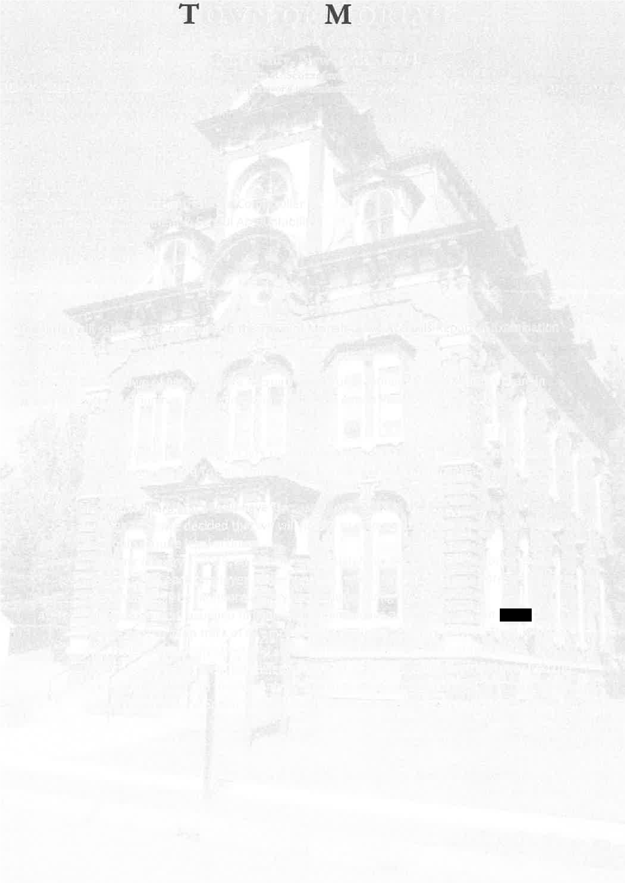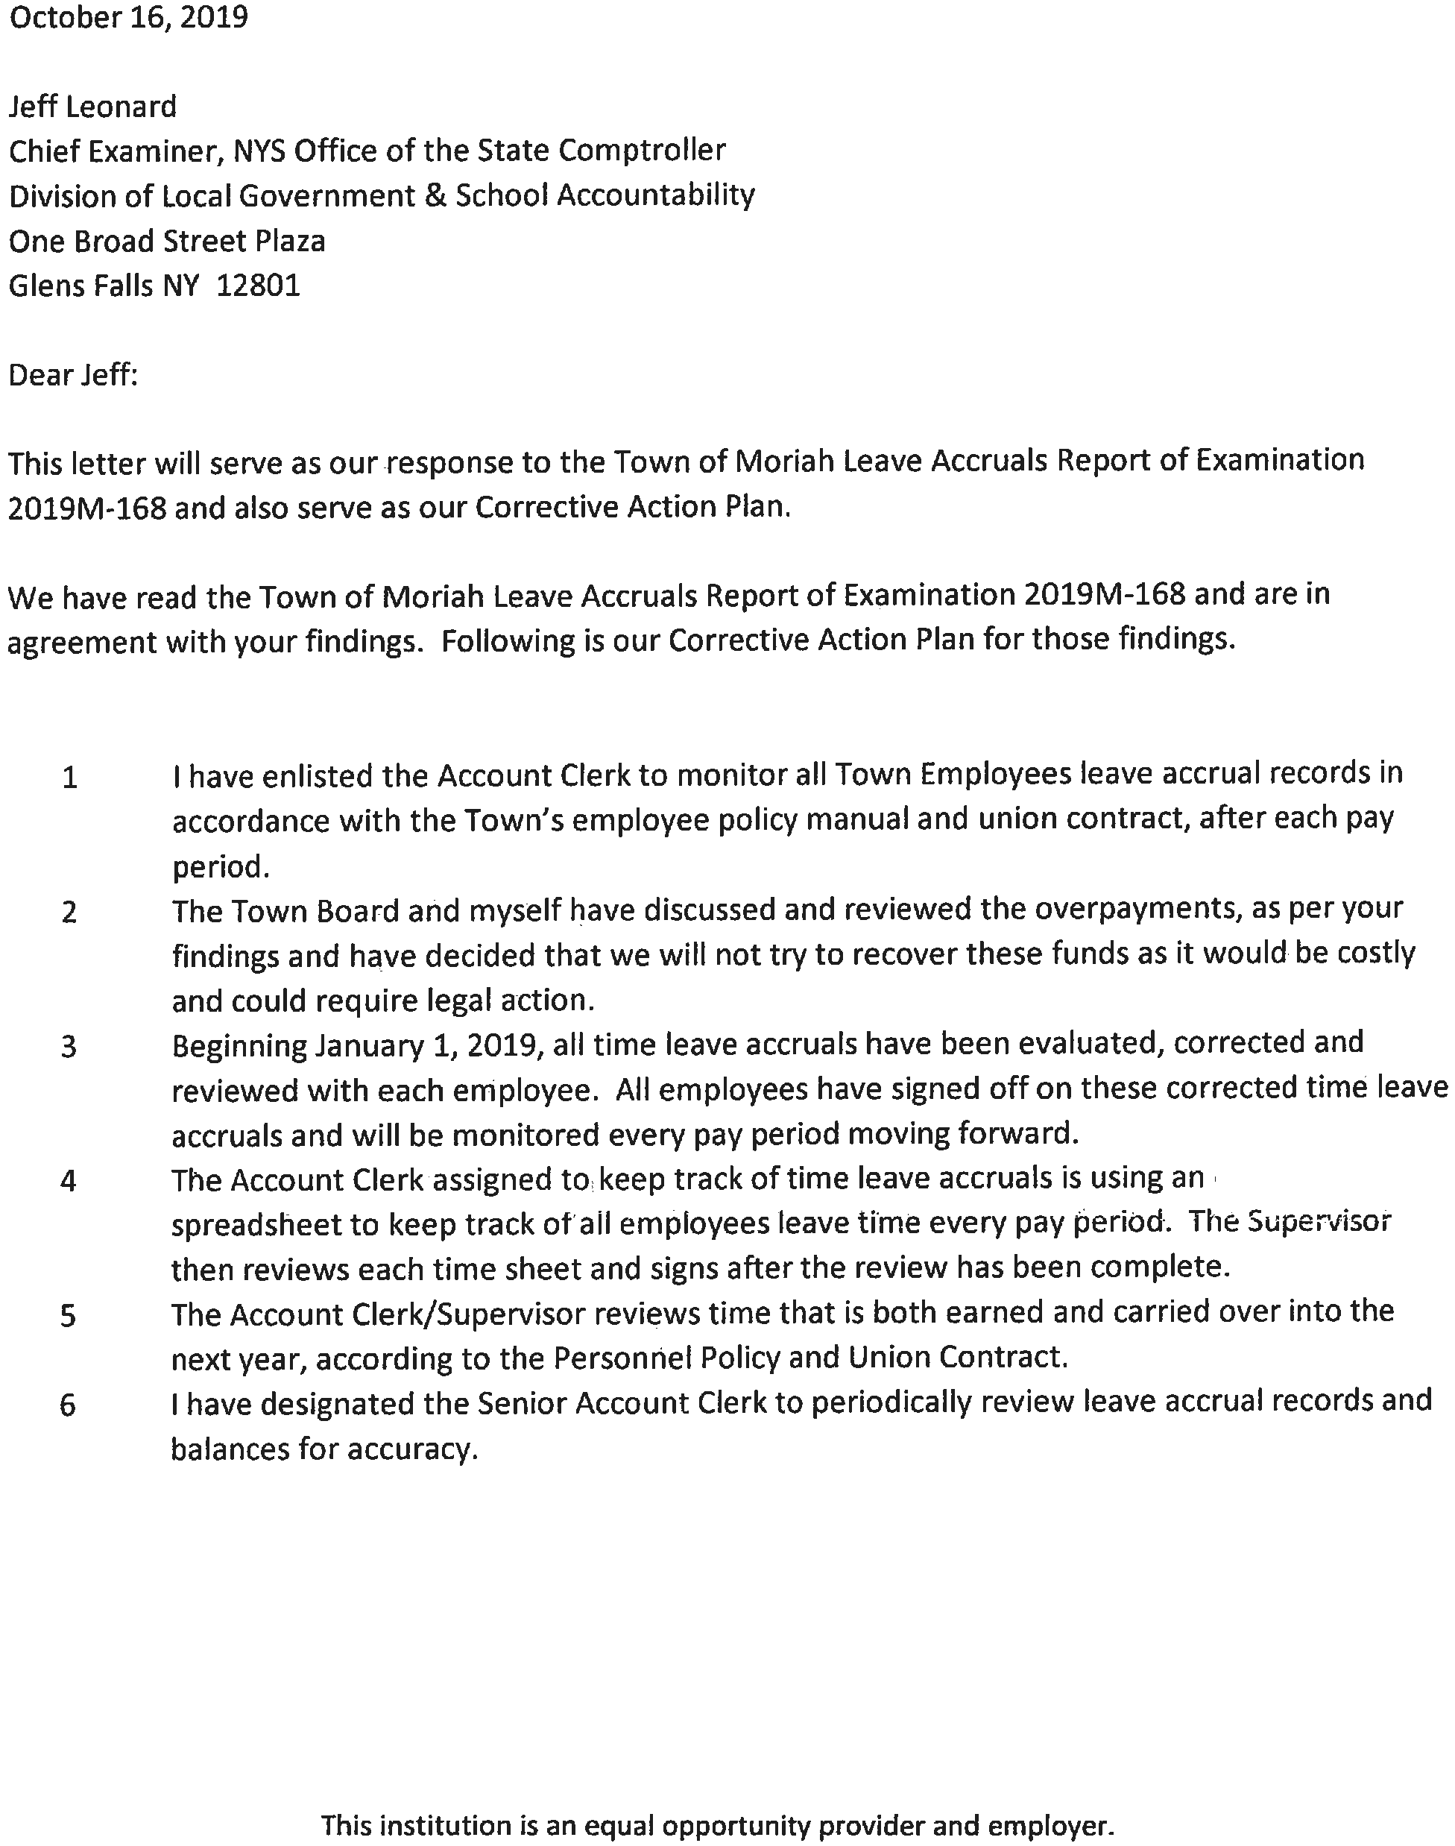

Appendix B: Audit Methodology and Standards

We conducted this audit pursuant to Article V, Section 1 of the State Constitution and the State Comptroller’s authority as set forth in Article 3 of the New York State General Municipal Law. To achieve the audit objective and obtain valid audit evidence, our audit procedures included the following:  We interviewed Town officials and employees and reviewed the Town’s employee policy manual, CBA and various records and reports to gain an understanding of procedures related to the maintenance of leave accrual records and any associated effects of deficiencies in those procedures.  We used our professional judgment to select a sample of 15 employees’ leave accrual records during the audit period to determine whether the leave time they recorded on their time records was properly deducted from their leave accrual balances. We also determined whether the amounts of leave credited and carried forward during 2018 and 2019 agreed with the Town’s employee policy manual or CBA. Our sample included employees from all of the Town’s departments.
We conducted this performance audit in accordance with GAGAS (generally accepted government auditing standards). Those standards require that we plan and perform the audit to obtain sufficient, appropriate evidence to provide a reasonable basis for our findings and conclusions based on our audit objective. We believe that the evidence obtained provides a reasonable basis for our findings and conclusions based on our audit objective.
Unless otherwise indicated in this report, samples for testing were selected based on professional judgment, as it was not the intent to project the results onto the entire population. Where applicable, information is presented concerning the value and/or size of the relevant population and the sample selected for examination.
A written corrective action plan (CAP) that addresses the findings and recommendations in this report should be prepared and provided to our office within 90 days, pursuant to Section 35 of General Municipal Law. For more information on preparing and filing your CAP, please refer to our brochure, Responding to an OSC Audit Report, which you received with the draft audit report. We encourage the Board to make the CAP available for public review in the Town Clerk’s office.

Appendix C: Resources and Services

Regional Office Directory
www.osc.state.ny.us/localgov/regional_directory.pdf
Cost-Saving Ideas – Resources, advice and assistance on cost-saving ideas www.osc.state.ny.us/localgov/costsavings/index.htm
Fiscal Stress Monitoring – Resources for local government officials experiencing fiscal problems
www.osc.state.ny.us/localgov/fiscalmonitoring/index.htm
Local Government Management Guides – Series of publications that include technical information and suggested practices for local government management www.osc.state.ny.us/localgov/pubs/listacctg.htm#lgmg
Planning and Budgeting Guides – Resources for developing multiyear financial, capital, strategic and other plans
www.osc.state.ny.us/localgov/planbudget/index.htm
Protecting Sensitive Data and Other Local Government Assets – A nontechnical cybersecurity guide for local government leaders www.osc.state.ny.us/localgov/pubs/cyber-security-guide.pdf
Required Reporting – Information and resources for reports and forms that are filed with the Office of the State Comptroller www.osc.state.ny.us/localgov/finreporting/index.htm
Research Reports/Publications – Reports on major policy issues facing local governments and State policy-makers www.osc.state.ny.us/localgov/researchpubs/index.htm
Training – Resources for local government officials on in-person and online training opportunities on a wide range of topics www.osc.state.ny.us/localgov/academy/index.htm
Contact
Office of the New York State Comptroller
Division of Local Government and School Accountability
110 State Street, 12th Floor, Albany, New York 12236
Tel: (518) 474-4037 • Fax: (518) 486-6479 • Email: localgov@osc.ny.gov www.osc.state.ny.us/localgov/index.htm
Local Government and School Accountability Help Line: (866) 321-8503

GLENS FALLS REGIONAL OFFICE – Jeffrey P. Leonard, Chief Examiner
One Broad Street Plaza • Glens Falls, New York 12801-4396
Tel (518) 793-0057 • Fax (518) 793-5797 • Email: Muni-GlensFalls@osc.ny.gov
Serving: Albany, Clinton, Essex, Franklin, Fulton, Hamilton, Montgomery, Rensselaer, Saratoga,
Schenectady, Warren, Washington counties
Like us on Facebook at facebook.com/nyscomptroller
Follow us on Twitter @nyscomptroller

Prior to January 1, 2019, employees who retired were paid one hour for every four hours of accrued unused sick leave at the employee’s hourly rate of pay at the time of retirement.
The 701.75 hours consisted of 102.5 hours of vacation leave, 523 hours of sick leave, 56 hours of personal leave and 20.25 hours of compensatory leave.
The 86.5 hours consisted of eight hours of vacation leave, 58 hours of sick leave and 20.5 hours of compensatory leave.
We also issued a separate audit report, Town of Moriah – Cash Management (2019M-169)

